**ARCADE SECRETARY**

**REACT, MVP HACKATHON 10 – 11 JUNE 2021**

**TEAM: HACK OVERFLOW**

**MEMBERS: ANTHONY M, ROBA, GIZELLE**

**DESCRIPTION**

**\*\*TOTAL TIMER STARTS AT 1 minute.** // WHERE TOTAL TIMER IS AFFECTED BY WORD TIMER**

Arcade Secretary is a score-based speed typing game. Secretaries are armed with their keyboards and lighting reflexes when they enter the fast-paced corporate battlefield where speed and accuracy pave the way to victory!

<br></br>

Secretaries are given a strict deadline during which they will be given words, which they must type and submit as quickly and as accurately as super-humanly possible. Once the secretary finishes typing a word, they must hit the space bar to submit their work before the next word task can be provided.

<br></br>

Secretaries will be awarded for accuracy and receive one point for each character they typed correctly, but only up until their first mistake! Mistakes are a liability. If a secretary makes a mistake, they will accrue one negative point for the error and each remaining word character.

<br></br>

Secretaries race against time! Each word has a time limit. If time runs out, the word will not be submitted and word length is deducted from score. The battle moves to the next word. If the secretary submits a word before the word timer runs out, the remaining time will be added to extend their total allocated time.

<br></br>

Secretaries race on until the total game timer runs out and the game ends when they reach their deadline.

<br></br>

Secretaries are then provided with a performance review which will include a positive or negative total score, total time, WPM (words per minute), average accuracy and average time per character.

<br></br>

Secretaries are immortal and live to battle again, always seeking to improve and chasing deadline victories.

Score based

- one point per correct word

- Calculate how many times word mistyped, deducts a point.

**“ARCADE SECRETARY”**

**As long as we get one word on scree and show accuracy then happy with that.**

**Use Dictionary API**

**GET as many points in the total given time.**

**You get a reward of added time for correct words. The remaining time on that word gets added to the total time.**

**Getting a word wrong you lose time and get negative points. And lose time remaining on the word.**

**Mistake – stop word and go to next word.**

**Switch statement for time or points.**

**Points: 300**

**WPM: 75**

**Accuracy: 85%**

**Total Time: 1.30**

**avg time per word: 4.6s**

**Total points**

**How many word correct**

**Show them their total time.**

**Give average points per minute**

**2 Timers :**

* Timer per word
* Total time

Deduct time

~~Anthony: Ticker on each word to check if user’s input box type matches word.~~

~~Roba: Compare length of words after finished.~~

~~Gizelle: Need whole para and spaces and punctuation is equally important.~~

**ACCURACY**

Accuracy: exactly as written in the provided text. More important than everything else.

Get it to work one word at a time. Then use similar logic.

Accuracy measured character by character – stop when

Once you make a typo you can’t finish the word. You get points per correct character and negative points for characters you didn’t get to.

Or can make them lose points if they don’t get more than 50%

**Paragraphs**

**Need API – Dictionary API**

**Accessibility** – black out words or change color once typed. But don’t change if incorrect.

**NICE TO HAVE**

* **Paragraphs with API**
* **Words typed**

**EXPANDABILITY**

* **Keyboard highlighting keys for people or kids learning typing**
* **Image of word being typed**
* **Gif as reward or punishment**
* **Make it harder with distractions**
* **Show those “are you human” blurred text and make you speed test it**

**GITHUB:**

**Created a github team – push everything to repo on that team and it’s finished you fork.**

**Create branch under your name with what you are doing. Eg Gizelle branch and dash description of what you are working on.**

**Anthony: Styling HTML and CSS. Style with class names.  
Roba: Coding JS**

**Wont work this time round.**

**As we type words,**

**Trello**

* **Wireframes - Anthony**
* **Create app and repository**
* **~~Link Dictionary API OR~~ Json data file**
* **Tasks**
* **Build timer**
* **How are we going to know if they much up spelling.** 
  + **Compare one by one (for loop or each)**
  + **+ 1 if matches**
  + **length of word**

**Modal or alert or hide rules.**

**Event – hit enter to start “onsubmit”.Length of word to indicate you finished typing the word.**

* **Check submitted word after hitting space (rather than). Controlled form? Input in a variable. Comparing strings – strings are an array of characters. You just iterate over it.**

**TRELLO**

**README**

**~~Word timer shouldn’t affect total timer? But if it does add time the game goes longer.~~**

**~~WHS –~~**

**~~///////////////////////////////////////////////////////////////////////////////////////////////~~**

**TASKS**

**GIZELLE**

* Build what I have and button: MAKE HOME PAGE FIRST with play button. HOM
  + HOME ROUTER HAS CONDITIONAL RENDERING INSIDE THE HOME COMPONENT: - Play; Game; Stats
  + APP COMPONENT ---NAV, 3 routers that render HOME, Rules and Contacts
  + HOME – 3 cases, 3 conditional renders. It depends on the phase of the game. Pre-game, game, scores [ROBA]

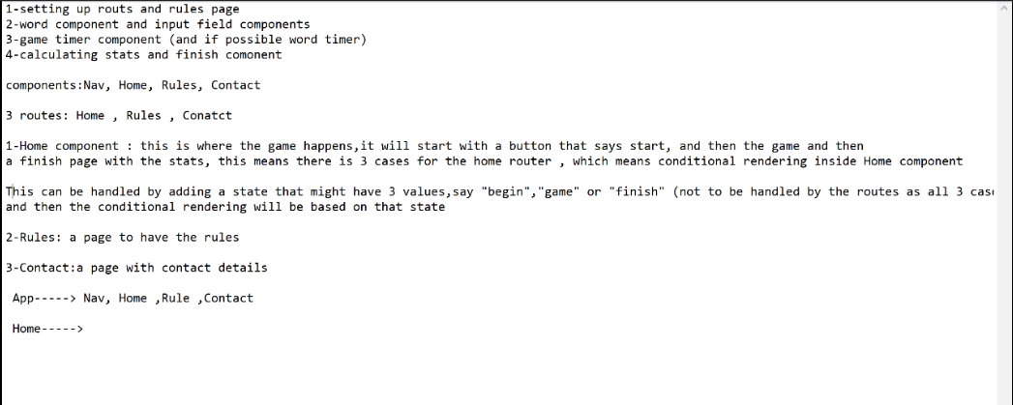

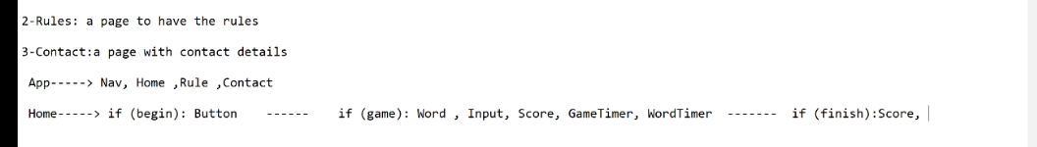

GAME PAGE HAS A STATE CALLED GAME STATE

1. BEGIN: SEE PLAY BUTTON
2. PLAY GAME
3. STATS AFTER

ONE COMPONENT: PLAY & REPLAY BUTTON change value of button from play to replay

ROBA will put this into the HOME PAGE:

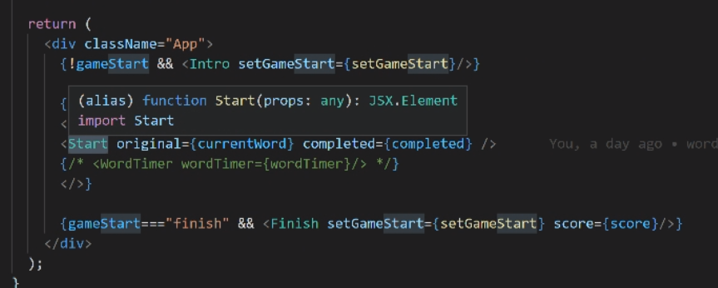

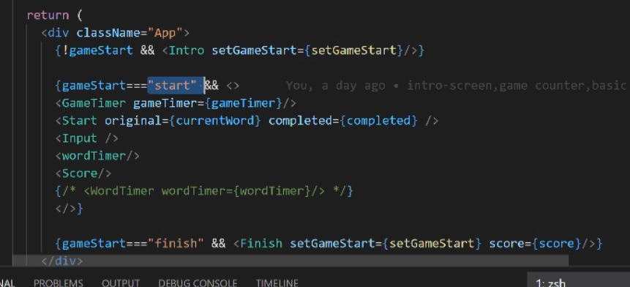

ANTHONY: SCORE stats

ROBA: TIMERS and WORD

GET ON YOUR BRANCH, MERGE FROM MAIN and resolve issues.

Check out own branch.



Pull changes form main branch so you have the latest

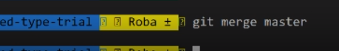

ONCE ALL done push to github on your branch



Make sure your master is updated.

IN SUMMARY:

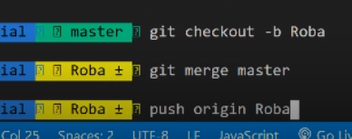

**ANTHONY INITIATE GITHUB REPO AND CREATE APP**

**GIZELLE SET UP HOME**

**ROBA WORKS IN HOME TO BUILD THE GAME**

